Course Specialist Test 4 Year 12

Student name: ________________ Teacher name: ________________

Task type: Response

Time allowed for this task: ____40_______ mins

Number of questions: _____7______

Materials required: Calculator with CAS capability (to be provided by the student)

Standard items: Pens (blue/black preferred), pencils (including coloured), sharpener, correction fluid/tape, eraser, ruler, highlighters

Special items: Drawing instruments, templates, notes on one unfolded sheet of
A4 paper, and up to three calculators approved for use in the WACE examinations

Marks available: _44_____ marks

Task weighting: _10___%

Formula sheet provided: Yes

Note: All part questions worth more than 2 marks require working to obtain full marks.

Q1 (3 & 3 = 6 marks)
Solve the following.
- given that when .

Solution
￼
Specific behaviours
P separates variables
P integrates all terms
P solves for constant

- given that when .

Solution
(c=+2/225)

Specific behaviours
P separates variables
P integrates all terms
P solves for constant

Q2 (4 marks)
An iron has a temperature of is left in a room, of temperature , to cool such that the temperature at time minutes is given by . After 15 mins the temperature of the iron is . Determine the time taken for the iron’s temperature to drop to .

Solution
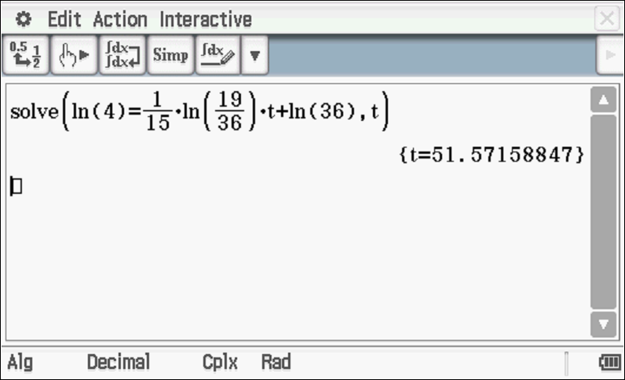

51.57 minutes
Specific behaviours
P separates variables and integrates
Pderives an expression involving both variables
P solves for both constants (may be approx.)
P determines approx time and must give units

Q3 (1, 5 & 2 = 8 marks)
The number thousands, of bacteria cells living in a petri dish at time hours is given by .
The initial number of cells was 2 thousand.
- What is the limiting value of the number of cells as ?

Solution
6 thousand

Specific behaviours
P states limiting value with units

- Using calculus and partial fractions, show every step to express in terms of .

Solution
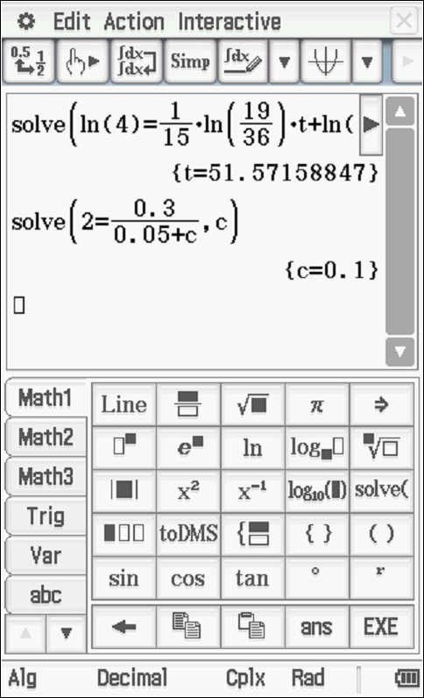

Specific behaviours
P separates variables
P uses partial fractions and shows working for constants
P shows why absolute value not needed for log function
P rearranges to make N the subject with a constant
Psolves for constant

- Determine the number of cells after 15 hours.

Solution
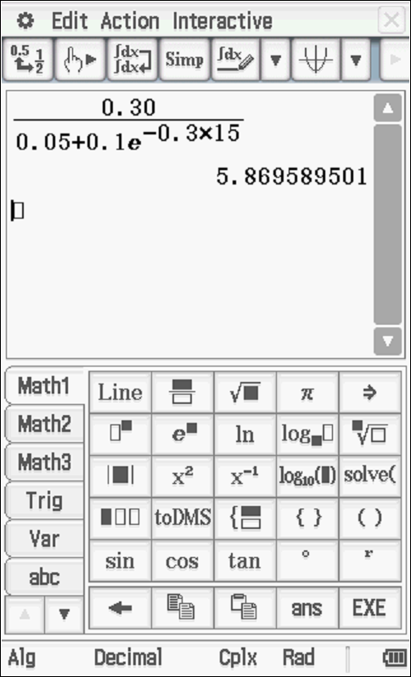

Approximately 5870 cells
Specific behaviours
P subs t=15 into rule from part b
P determines quantity with units of thousands or 5870 cells
(Note –max –1 for units for entire question)

Q4 (3, 2 & 2 = 7 marks)
Consider the slope field
- Sketch this field on the axes below.

Solution
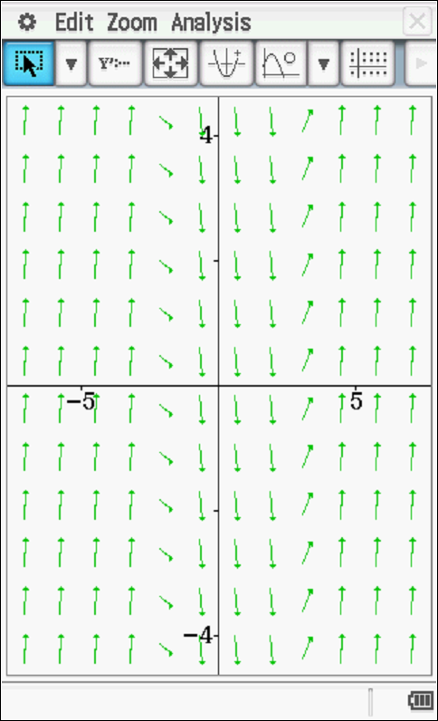

Specific behaviours
P shows horizontal grads at x=-2
P shows horizontal grads at x=3
P pattern at far left and right

- Draw the solution curve, axes above, that contains the point (1,1).
Solution
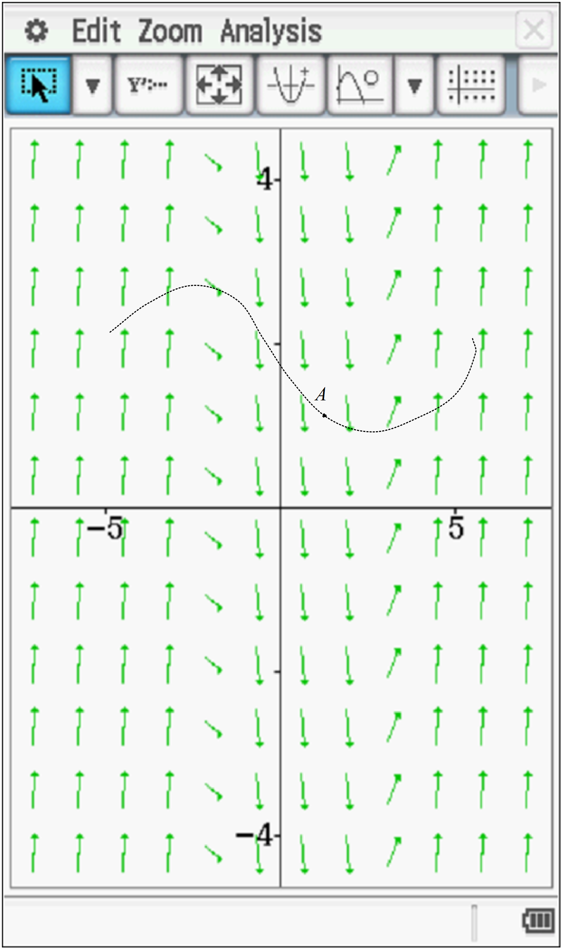

Specific behaviours
P shape of solution curve
P shows pt A labelled on curve

- Determine the equation of the solution curve that contains (1,1).
Solution
Specific behaviours
P integrates x terms
P solves for constant

Q5 (2, 2 & 3 = 7 marks)
Consider an object that is moving with Simple Harmonic Motion such that with in metres and seconds respectively. At , metres and is a rest.
- Determine a rule for in terms of .

Solution
Specific behaviours
P uses an appropriate trig function
P states all constants

- Determine the exact speed when metres.

Solution
Specific behaviours
P uses appropriate rule
P states exact speed, ignore units

- Determine the percentage of the time, to one decimal place, that the object is less than 3 metres from the mean position, .

Solution
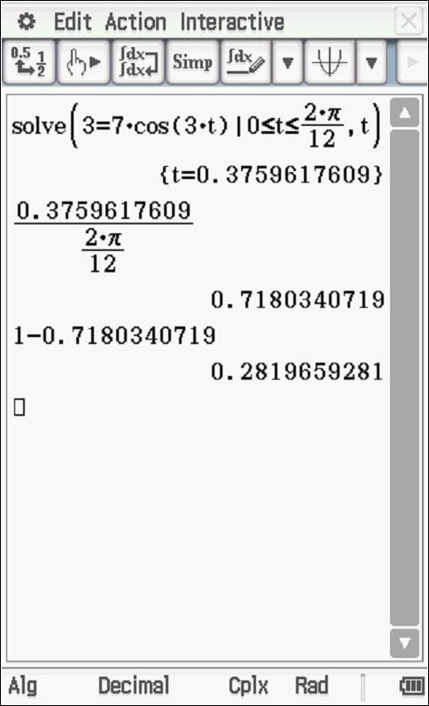

Specific behaviours
P solves for times at x=3 in a cycle or part cycle
P determines an interval time and then divides by total length of cycle or part cycle
P determines percentage

Q6 (4 marks)
Consider an object that is initially at the origin and at rest such that its acceleration is given by where equals the speed in at seconds . Determine the exact speed when its displacement from the origin is metres.

Solution
Specific behaviours
P separates variables and uses appropriate form of acceleration
P integrates and uses a constant
P solves for constant
P determines exact speed

Q7 (2, 3 & 3 = 8 marks)
A lolly company makes jelly beans where the mass of one jelly bean is normally distributed with a mean of 23.4 mg and a standard deviation of 3.2 mg. (Note: 1g=1000mg)
- Determine the probability to two decimal places that the total mass of 85 jelly beans is more than two grams.

Solution
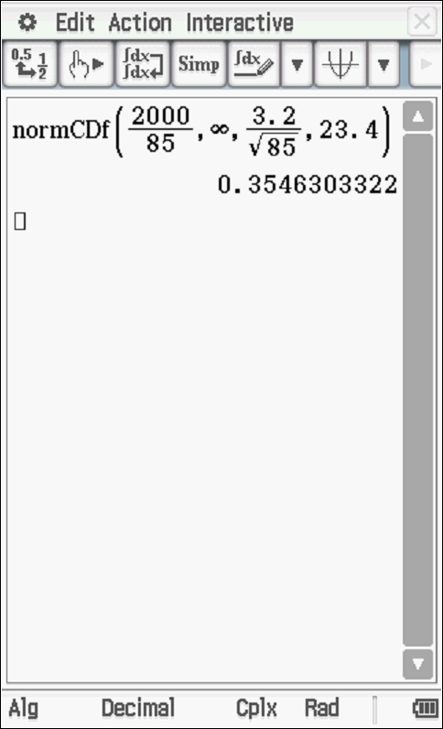
Prob=0.35

Specific behaviours
P uses correct parameters
P determines prob to 2 dp

- Given that the probability that the mean mass of a jelly bean differs from the population mean by more than 0.35 mg is 5%, determine , the number of jelly beans that need to be sampled.

Solution
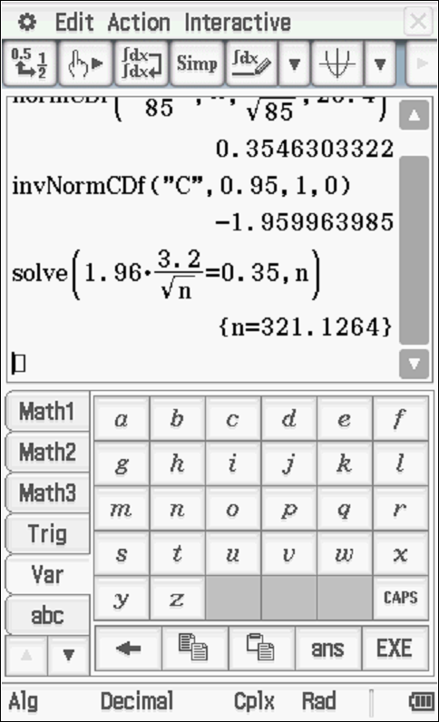
Sample size = 322

Specific behaviours
P states correct z score (must show)
P sets up equation for n
P rounds up

- On a particular day the operator of a machine that makes jelly beans is suspected of being faulty. A sample of 200 jelly beans had a sample standard deviation of 3.8 mg with a total mass of 5.4 grams. Present a mathematical argument to either support or to dismiss such a claim.
Solution

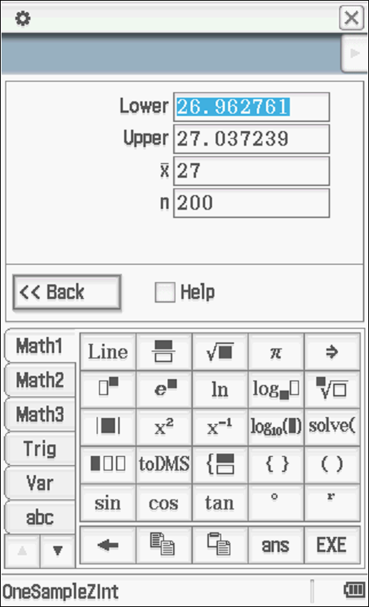
23.4 does not lie in interval hence there is evidence that machine is faulty and a different population mean is likely.
OR
As not every confidence interval contains the true value of mean, no inference can be made on one confidence interval

Specific behaviours
P determines a confidence interval for population mean using sample given.
P looks to see if 23.4 lies in interval or discusses that not every interval contains
P states that fault is likely as 23.4 lies outside interval OR no inference possible

